Bakersfield College
Certificate of Achievement in Industrial Drawing

Current Supply numbers:
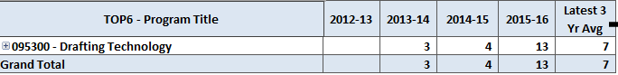

Current Demand in Industrial Drawing & Related fields:
